**File Encryptor Project Requirements**

Jacob Braddock

Cybersecurity

Dr. Michael O’Neil

May 2025

1. Scope of Project

i. Project Use Case

2. Functional

3. Look and Feel

i. Appearance

ii. Style

4. Usability

i. Ease of Use

ii. Personalization and Internationalization

iii. Learning

iv. Understandability and Politeness

v. Accessibility

vi. Convenience

5. Security

i. Access

ii. Integrity

iii. Privacy

iv. Audit

v. Immunity

1. Scope of Project
2. Project Use Case

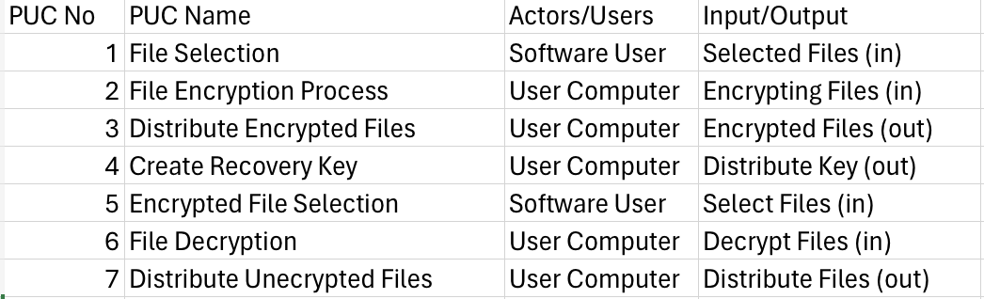

2. Functional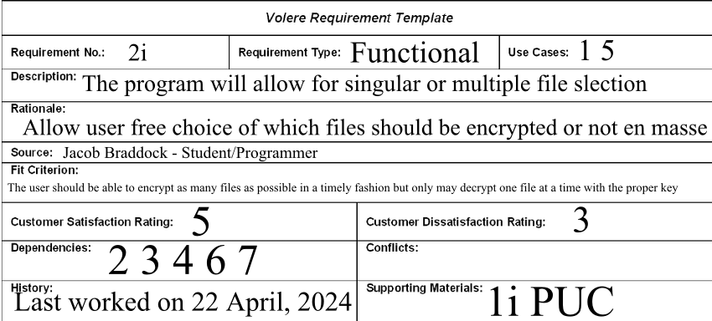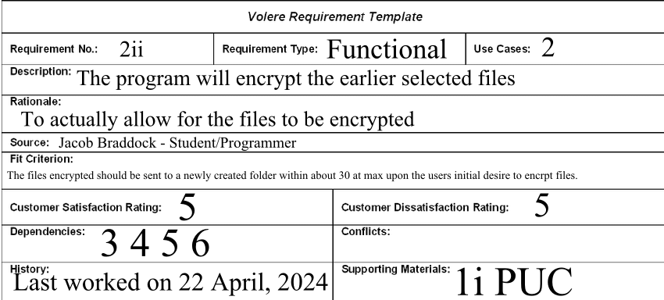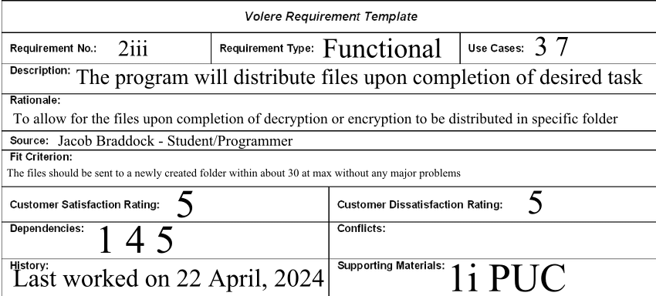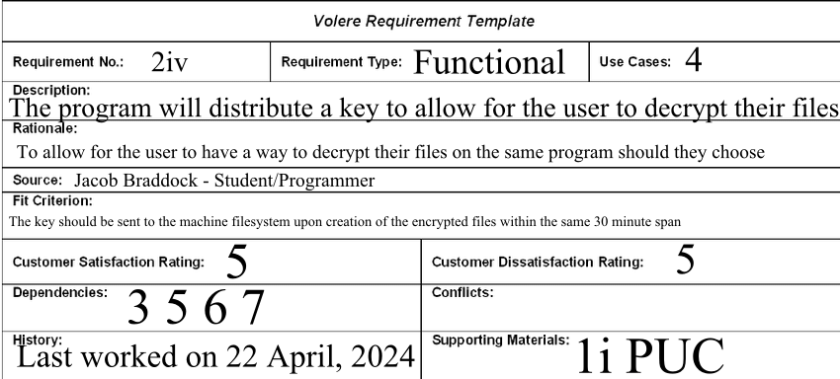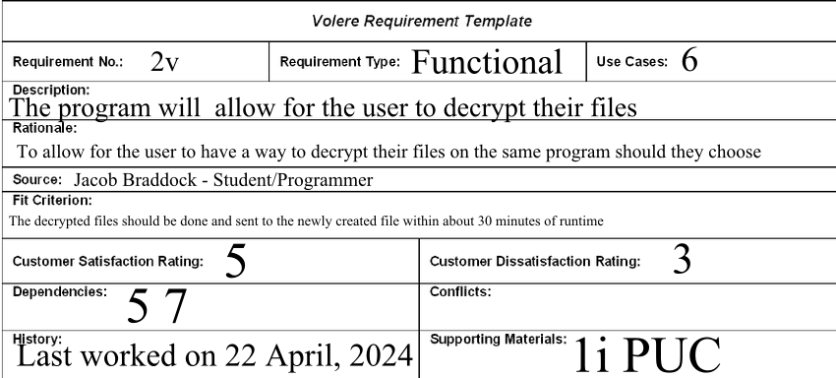

3. Look and Feel

**3i. Appearance**

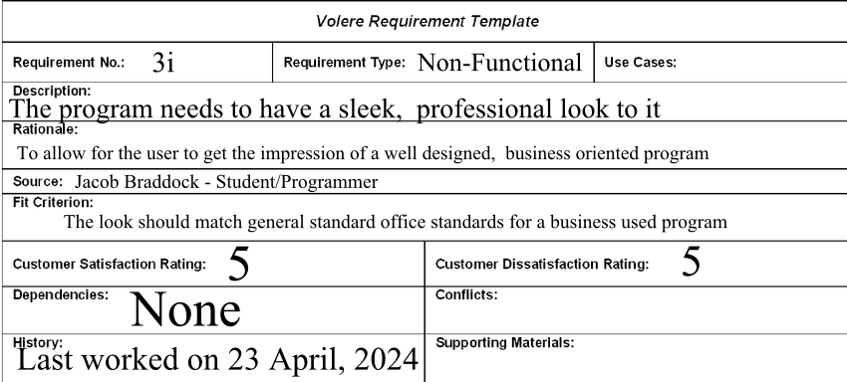

**3ii. Style**

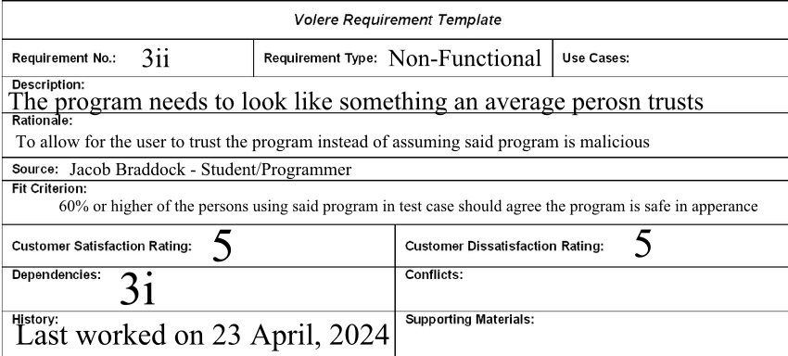

4. Usability

**i. Ease of Use**

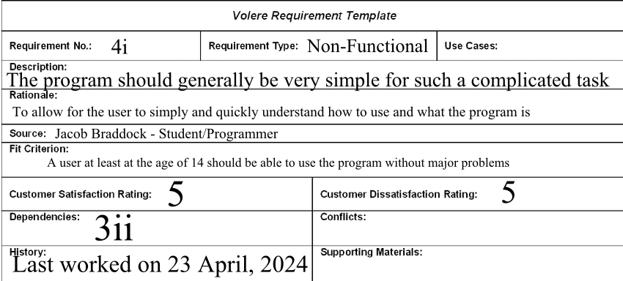

**ii. Personalization and Internationalization**

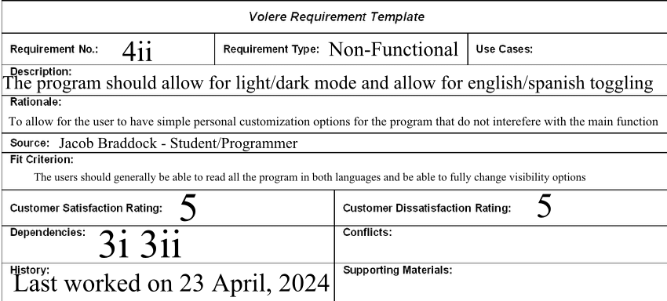

**iii. Learning**

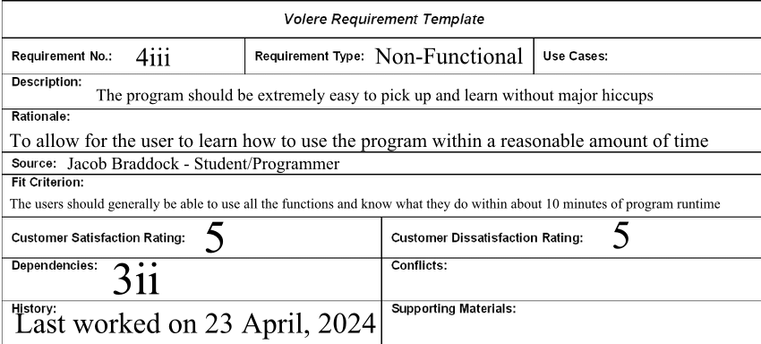

**iv. Understandability and Politeness**

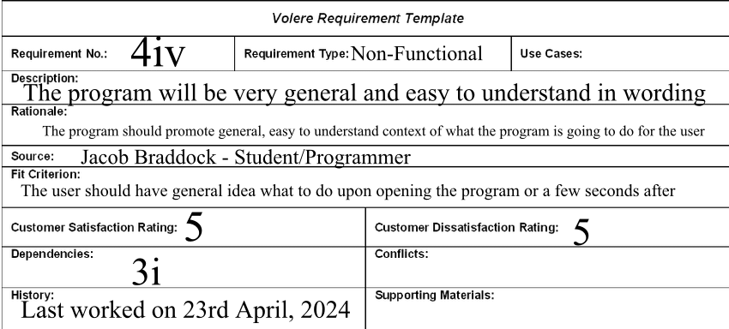

**v. Accessibility**

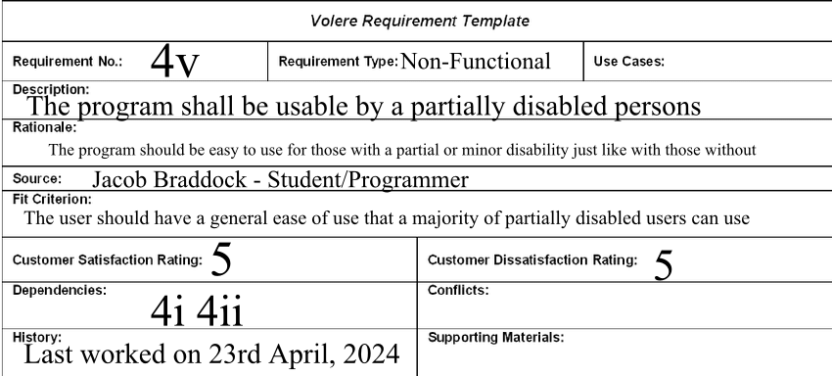

**vi. Convenience**

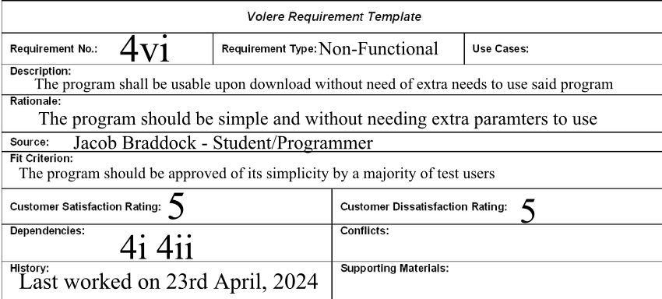

5. Security

**5i. Access**

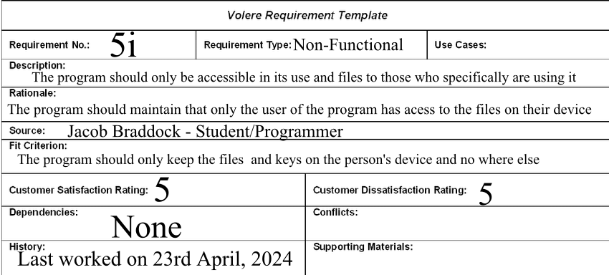

**5ii. Integrity**

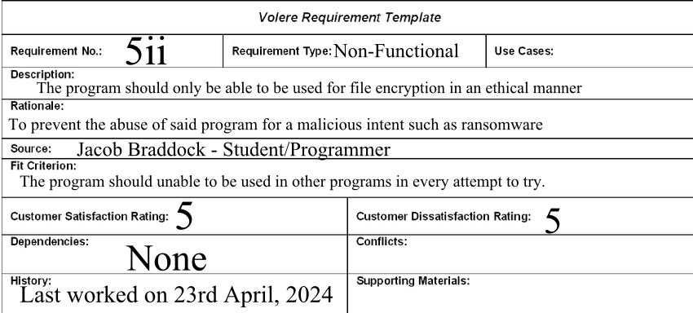

**5iii. Privacy**

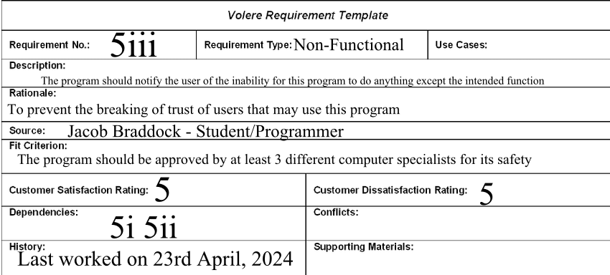

**5iv. Audit**

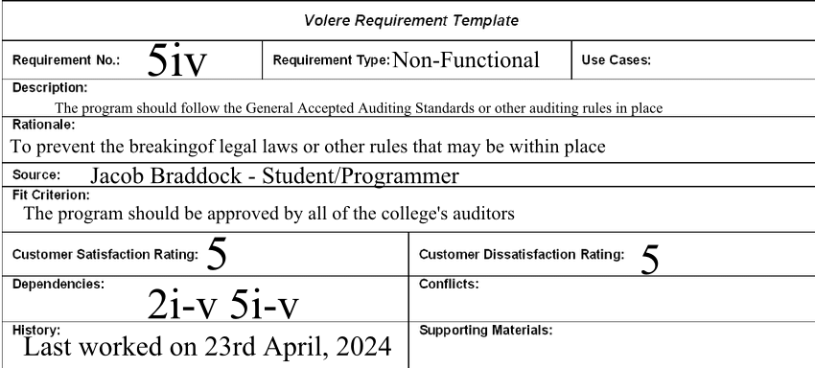

**5v. Immunity**

